-- 2. Given a passenger’s last name and first name and retrieve all trains they are booked on.

SELECT

P.First_name, P.Last_name, T.Train_number, T.Train_name, TS.Train_date

FROM

PASSENGER P, TRAIN T, TRAIN_STATUS TS

JOIN

BOOKED B ON P.Ssn = B.Passenger_ssn

WHERE

P.Last_name = "Parker" AND P.First_name = "Emily";

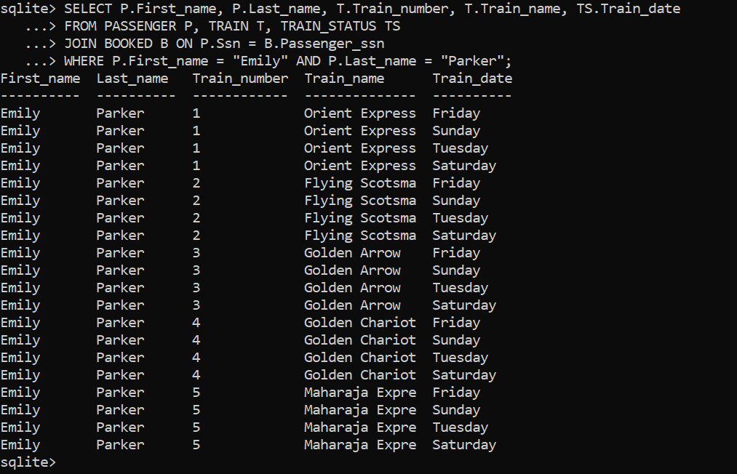

--3. Given a day list the passengers traveling on that day with confirmed tickets.

SELECT

P.First_name, P.Last_name, B.Train_Num, B.Status

FROM

PASSENGER P, BOOKED B

JOIN

TRAIN T ON B.Train_Num = T.Train_number

JOIN

TRAIN_STATUS TS ON T.Train_name = TS.Train_title

WHERE

TS.Train_date = "Sunday" AND B.Passenger_ssn = P.Ssn AND B.Status = "Booked";

--4. Display the train information (Train Number, Train Name, Source and Destination) and passenger information (Name, Address, Category, ticket status) of passengers who are between the ages of 50 to 60.

SELECT

T.Train_number, T.Train_Name, T.Source_Station, T.Destination, P.First_name, P.Last_name, P.Address, B.Ticket_Type, B.Status

FROM

TRAIN T, PASSENGER P, BOOKED B

WHERE

T.Train_number = B.Train_Num AND P.Ssn = B.Passenger_ssn AND P.Bdate > 1963-10-06 AND P.Bdate < 1973-10-06;

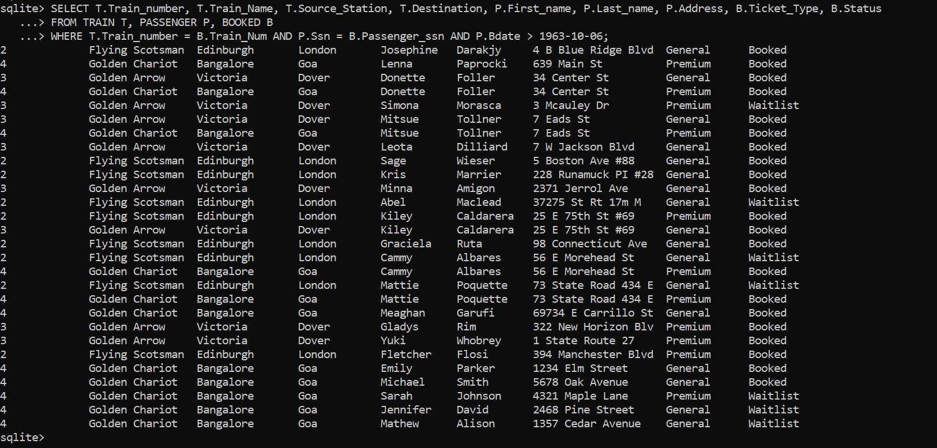

--5. List train name, day and number of passenger on that train.

SELECT

t.Train_name,

ts.Train_date AS Day,

COUNT(b.Passenger_ssn) AS Number_of_Passengers

FROM

TRAIN t

JOIN

TRAIN_STATUS ts ON t.Train_name = ts.Train_title

LEFT JOIN

BOOKED b ON t.Train_number = b.Train_num

GROUP BY

t.Train_name, ts.Train_date;

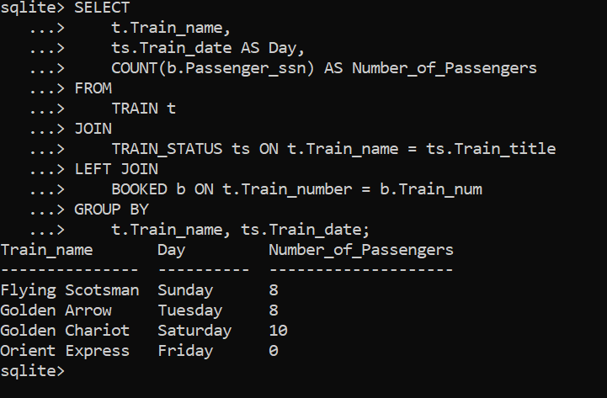

--6. Enter a train name and retrieve all the passengers with confirmed status traveling on that train.

SELECT

P.First_name,

P.Last_name,

P.Ssn,

B.Ticket_type,

B.Status

FROM

BOOKED B

JOIN

PASSENGER P ON B.Passenger_ssn = P.Ssn

JOIN

TRAIN T ON B.Train_num = T.Train_number

WHERE T.Train_name = 'Flying Scotsman' AND B.Status = 'Booked';

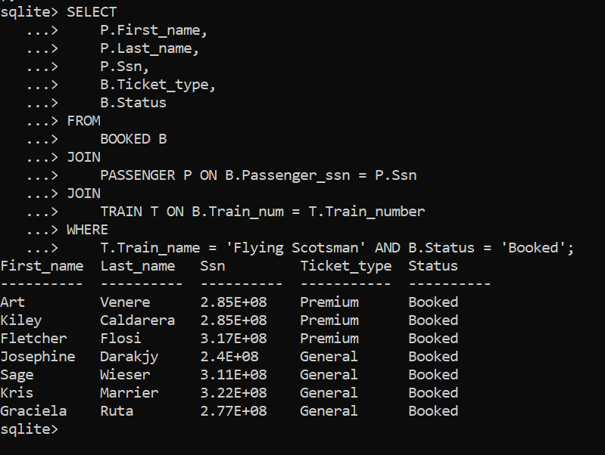

--7. List passengers that are waitlisted including the name of the train.

SELECT

P.First_name,

P.Last_name,

T.Train_name AS Train_name

FROM

PASSENGER P

JOIN

BOOKED B ON P.Ssn = B.Passenger_ssn

JOIN

TRAIN T ON B.Train_num = T.Train_number

WHERE

B.Status = 'Waitlist';

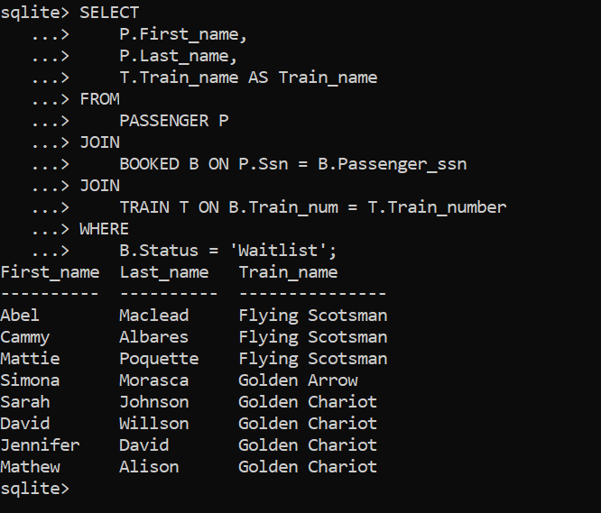

--8. List passenger names in descending order that have '605' phone area code.

SELECT

First_name,

Last_name

FROM

PASSENGER

WHERE

Phone_number LIKE '605%'

ORDER BY

First_name DESC, Last_name DESC;

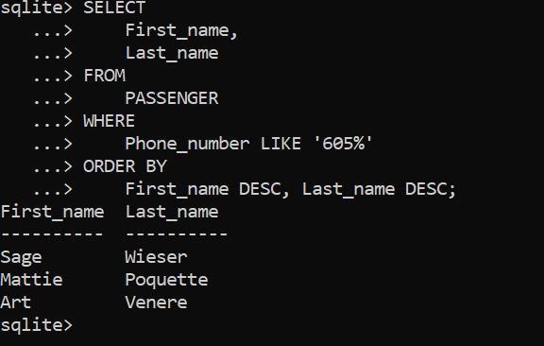

--9. List name of passengers that are traveling on Thursdays in ascending order.

SELECT

P.First_name,

P.Last_name

FROM

PASSENGER P, BOOKED B

JOIN TRAIN T ON B.Train_num = T.Train_number

JOIN TRAIN_STATUS TS ON T.Train_name = TS.Train_title

WHERE

TS.Train_date = "Thursday" AND

B.Passenger_ssn = P.Ssn

ORDER BY

P.First_name, P.Last_name;

